Grazioso Salvare
CS 340 Project Two | README and Reproduction Guide
Jordon Osborne

Project Overview
This dashboard helps Grazioso Salvare identify animal shelter dogs that may be suitable for search-and-rescue training. It retrieves Austin Animal Center Outcomes records from MongoDB and provides rescue-category filters, an interactive data table, a breed-frequency chart, and a map for a selected animal.

Features and Verified Behavior
- Reset returns the full 10,001-record data set.
- Water Rescue returned 17 matching records.
- Mountain or Wilderness Rescue returned 15 matching records.
- Disaster or Individual Tracking returned 21 matching records.
- The data table supports paging, sorting, filtering, and row selection; a breed chart and geographic map are displayed below it.

Architecture and Tool Selection
MongoDB is the model layer: its document-oriented records fit shelter data and allow flexible filtering. PyMongo connects Python to MongoDB through the AnimalShelter CRUD module, separating database access from presentation. Pandas converts query results into table-ready data. Dash/JupyterDash supplies the view and controller through radio buttons, data tables, and callbacks. Plotly Express renders the breed chart, while dash-leaflet provides the interactive location map. JupyterLab in Codio is used to run and test the notebook.

How to Reproduce the Dashboard
1. Open a Codio environment with Python, JupyterLab, and MongoDB available.
2. Load the supplied Austin Animal Center Outcomes dataset into the MongoDB collection configured by the CRUD module. Include location_lat, location_long, and age_upon_outcome_in_weeks fields.
3. Place ProjectTwoDashboard_Final.ipynb, CRUD_Python_Module.py, and Grazioso_Salvare_Logo.png in the same working directory.
4. Configure the aacuser MongoDB account and matching connection settings in the CRUD module. Keep real passwords out of any public GitHub repository.
5. Install required packages if missing: pandas, pymongo, dash, jupyter-dash, plotly, and dash-leaflet.
6. Open ProjectTwoDashboard_Final.ipynb and run the dashboard code in JupyterLab. In Codio, access the app using the Codio preview address on the configured port (8050 in the tested session), not the browser’s own 127.0.0.1.
7. Test each radio-button filter, select an animal row, and verify the data table, chart, and map update.

Challenges and Solutions
The dashboard initially showed connection errors when opening 127.0.0.1 in a separate browser. This was resolved by running the Dash server on host 0.0.0.0, port 8050, and opening the Codio port-specific preview URL. The logo initially appeared as plain text because its filename was not being found; checking the working directory revealed a mismatched image filename, which was corrected. The logo then displayed properly. Filter outputs were tested for each rescue category.

Testing Screenshots
The screenshots below were captured during the Codio dashboard tests. The chart/map image provides additional visual evidence; screenshots showing the entire dashboard and both charts together may be added if required.

Starting state / Reset — 10,001 records
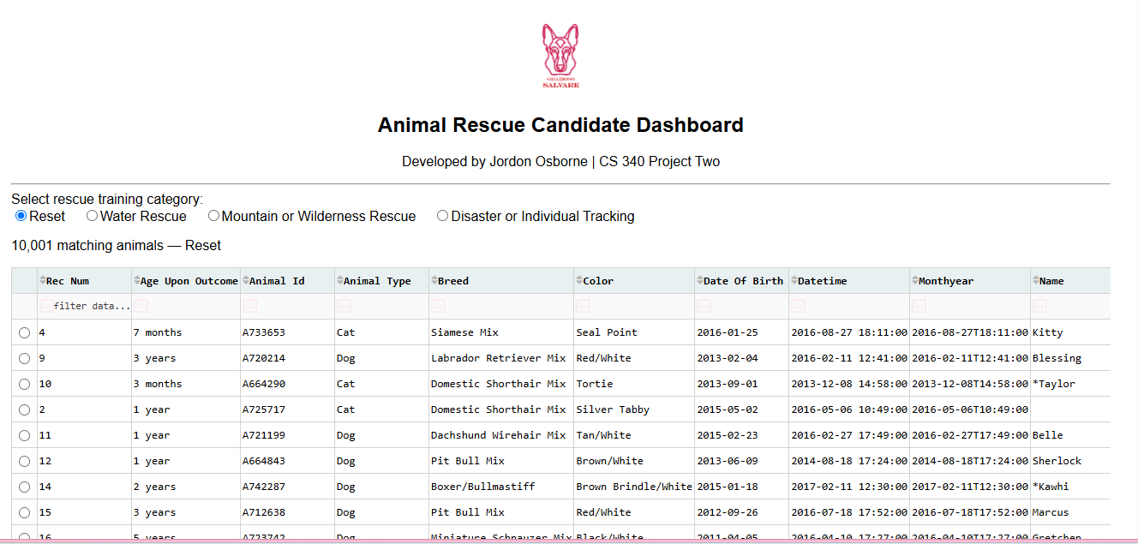

Water Rescue — 17 records
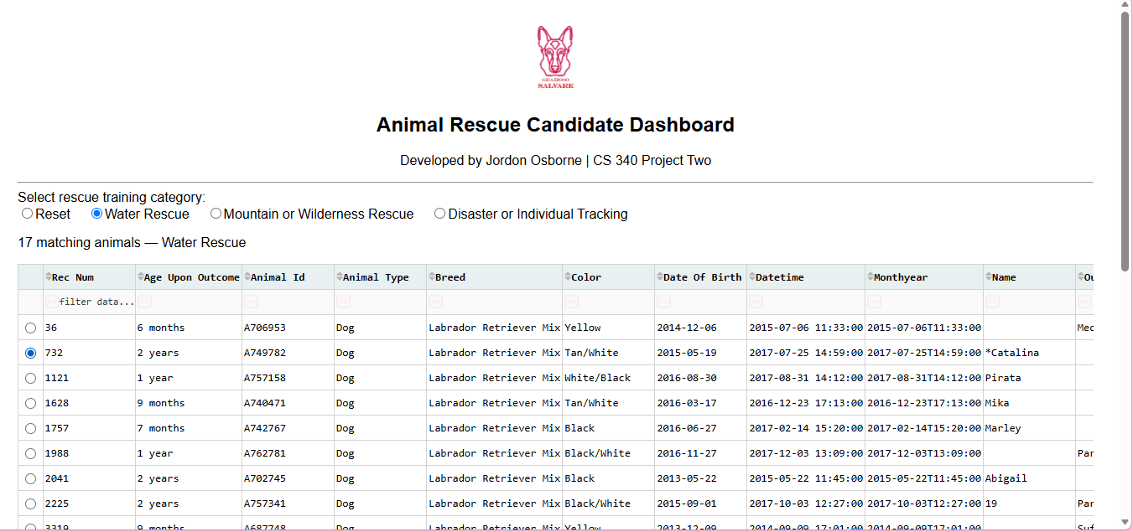

Mountain or Wilderness Rescue — 15 records
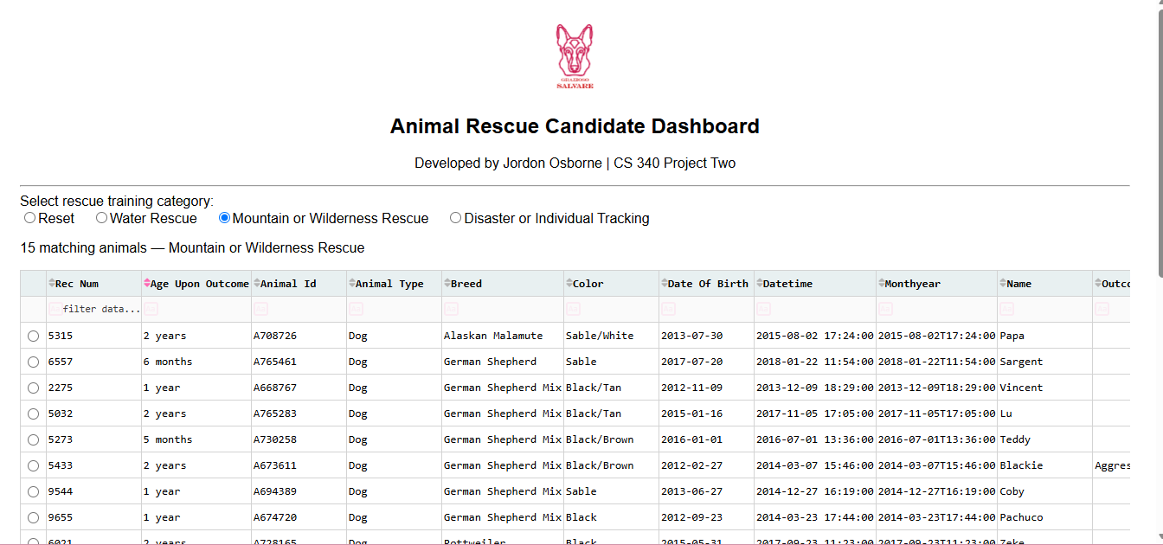

Disaster or Individual Tracking — 21 records
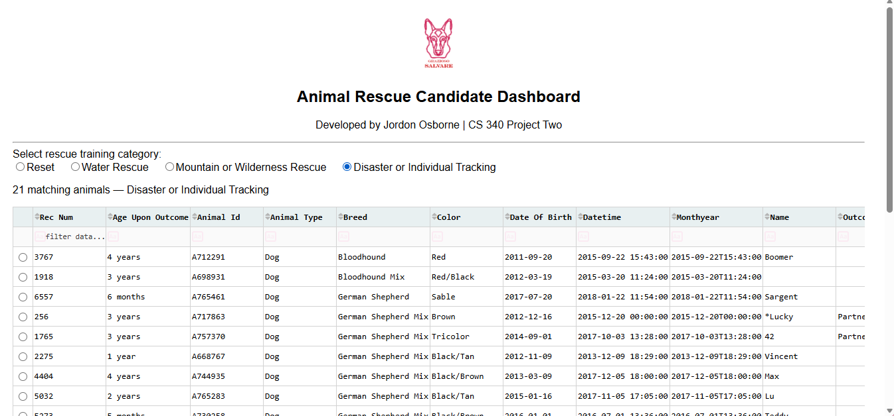

Breed chart and location map (Water Rescue)
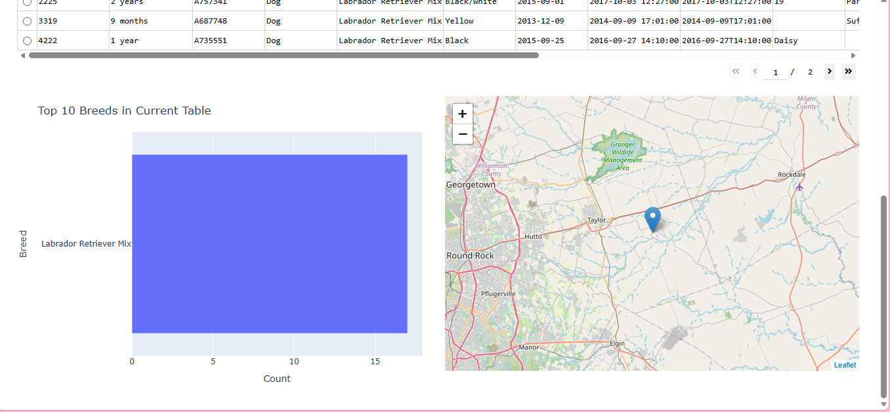

Resources
MongoDB documentation: https://www.mongodb.com/docs/
PyMongo documentation: https://pymongo.readthedocs.io/
Dash documentation: https://dash.plotly.com/
Plotly Python: https://plotly.com/python/
Dash Leaflet: https://www.dash-leaflet.com/
Python PEP 8: https://peps.python.org/pep-0008/
Austin Animal Center. (2020). Austin Animal Center Outcomes [Data set]. https://doi.org/10.26000/025.000001

